**Assignment No:-2**

**Problem Statement:-**

Perform the following operations using R/Python on the data sets:

a) Compute and display summary statistics for each feature available in the dataset. (e.g.

minimum value, maximum value, mean, range, standard deviation, variance and

percentiles

b) Data Visualization-Create a histogram for each feature in the dataset to illustrate the

feature distributions.

c) Data cleaning, Data integration, Data transformation, Data model building (e.g.

Classification)

**Theory**:-

Data analysis and modeling involve a series of steps aimed at understanding the underlying patterns and relationships within a dataset, and building predictive or descriptive models to extract insights or make decisions. In this section, we will discuss various aspects of data analysis and modeling, including summary statistics, data visualization, data cleaning, integration, transformation, and model building.

a) Summary Statistics

Summary statistics provide a concise overview of the distribution and characteristics of each feature (variable) in a dataset. Common summary statistics include measures such as the minimum value, maximum value, mean, range, standard deviation, variance, and percentiles. These statistics help in understanding the central tendency, spread, and shape of the data distribution. Calculating summary statistics is the initial step in exploratory data analysis (EDA) and provides insights into the data before further analysis.

b) Data Visualization

Data visualization is a powerful technique for representing data graphically to gain insights and communicate findings effectively. Histograms are a commonly used visualization tool to illustrate the distribution of each feature in a dataset. A histogram displays the frequency or count of data points within predefined intervals or bins along the range of values of the feature. By visualizing feature distributions, patterns such as skewness, multimodality, outliers, and gaps can be identified, aiding in data exploration and understanding.

c) Data Cleaning, Integration, Transformation

Data preprocessing is a crucial step in data analysis and modeling to ensure that the dataset is clean, consistent, and suitable for analysis. Data cleaning involves handling missing values, outliers, duplicates, and inconsistencies in the dataset. Data integration combines data from different sources or formats into a unified dataset. Data transformation involves converting, scaling, or normalizing features to make them suitable for analysis and modeling. These preprocessing steps help in improving the quality and reliability of the data, leading to better model performance.

d) Data Model Building (Classification)

Model building is the process of developing mathematical or computational models that capture the underlying patterns and relationships in the data. Classification is a type of supervised learning task where the goal is to predict the class labels of instances based on their features. Common classification algorithms include logistic regression, decision trees, random forests, support vector machines (SVM), and neural networks. The model-building process typically involves splitting the dataset into training and testing sets, selecting appropriate features, choosing a suitable algorithm, training the model on the training set, evaluating its performance on the testing set, and fine-tuning the model parameters for better performance.

**Methodology:**

1. Compute and Display Summary Statistics:
   * Python (using pandas):
     + Use describe() function to compute summary statistics.
2. Data Visualization - Histogram Creation:
   * Python (using matplotlib or seaborn):
     + Use hist() function to create histograms for each feature.
3. Data Cleaning, Integration, Transformation, Model Building:
   * Data Cleaning:
     + Identify and handle missing values using techniques such as imputation or deletion.
   * Data Integration:
     + Merge or join multiple datasets based on common variables.
   * Data Transformation:
     + Normalize or scale features, encode categorical variables, and handle outliers.
   * Model Building:
     + Split data into training and testing sets.
     + Choose an appropriate machine learning algorithm (e.g., classification algorithm).
     + Train the model on the training data and evaluate its performance on the testing data.

Advantages and Disadvantages & Limitations/Example:

1. Advantages:
   * Summary Statistics:
     + Provides a quick overview of the dataset's characteristics.
     + Helps in identifying outliers and understanding the distribution of features.
   * Data Visualization:
     + Enables intuitive understanding of feature distributions.
     + Facilitates identification of patterns and trends in the data.
   * Data Cleaning, Integration, Transformation, Model Building:
     + Enhances data quality and prepares it for analysis.
     + Facilitates the development of predictive models for classification tasks.
2. Disadvantages & Limitations/Example:
   * Summary Statistics:
     + May not capture all nuances of the data distribution, especially in complex datasets.
     + Outliers can skew summary statistics, affecting their interpretability.
   * Data Visualization:
     + Histograms may not provide sufficient detail for understanding complex relationships.
     + Interpretation of histograms can be subjective and influenced by binning choices.
   * Data Cleaning, Integration, Transformation, Model Building:
     + Data cleaning and transformation can be time-consuming, especially for large datasets.
     + Model performance heavily depends on data quality, feature selection, and algorithm choice.

**Diagram**

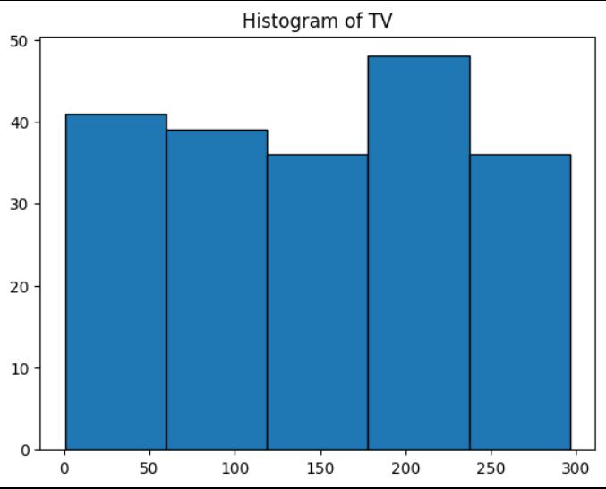

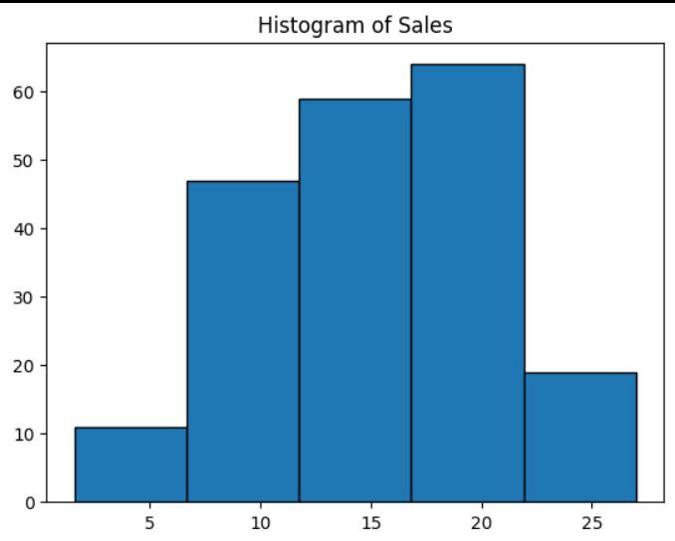

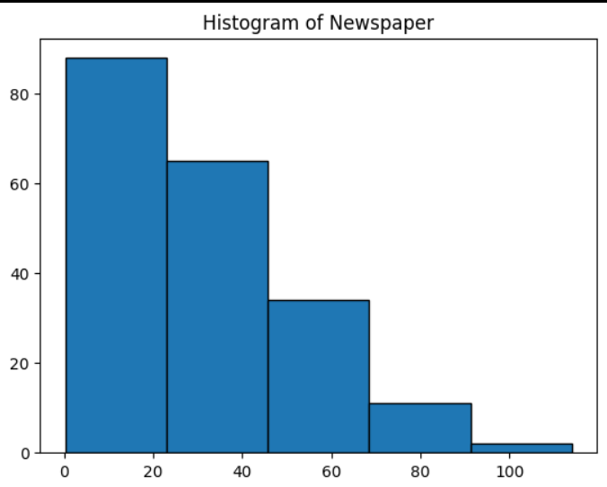

**Conclusion**

The methodology involves using R and Python for data analysis, including computing summary statistics, creating histograms, and cleaning and transforming data for classification modeling. Though versatile, these methods might oversimplify data and lack detailed insights. However, they can still provide valuable insights for decision-making when used carefully.